The Death of SaaS
How AI will rewrite the rules of software, again

The Death of SaaS

How AI will rewrite the rules of software, again
 Aki Ranin
6 min read
·
Jun 21, 2024
At the beginning of my career, we didn’t have SaaS.
Tech companies would just build whatever they needed. Even smaller businesses had things like home-baked hour sheets, CRMs, or even ERPs. This is how we got “legacy software”. Mostly they were terrible, built by a rotation of poorly motivated summer interns, and everyone complained all the time.
Then SaaS happened. Just like there’s an app for that, there’s for sure a SaaS for that.
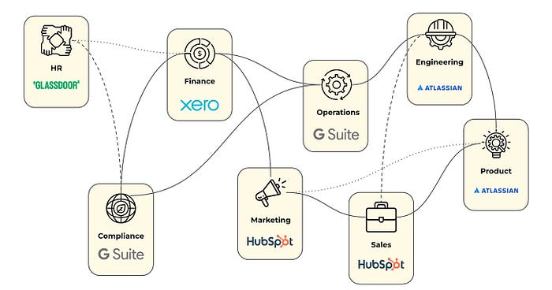
Now the basic startup operating system is a spiderweb of SaaS. And as any founder will attest, the bills add up really quickly. I guarantee there are SaaS tools used by your business right now your CFO has never even heard of. You do have a CFO, right? Right?!
The worst part is these guys are so fat on their gross margins, they don’t even innovate. I’ve used JIRA for most of my career, and it literally looks exactly the same when I started. All they did was move the same ugly software onto the cloud ten years ago. Possibly made some button edges rounder. Just slightly.
This has gotten so out of hand, that we need SaaS to manage your SaaS bills. I’m not kidding.

